*prime number and prime number using anonymous function

this keyword

*js class (briefly):-

1. API - Hit api - JSON String- Parse to JSONObj2. JSONObj - Single or [] get the value - iterate

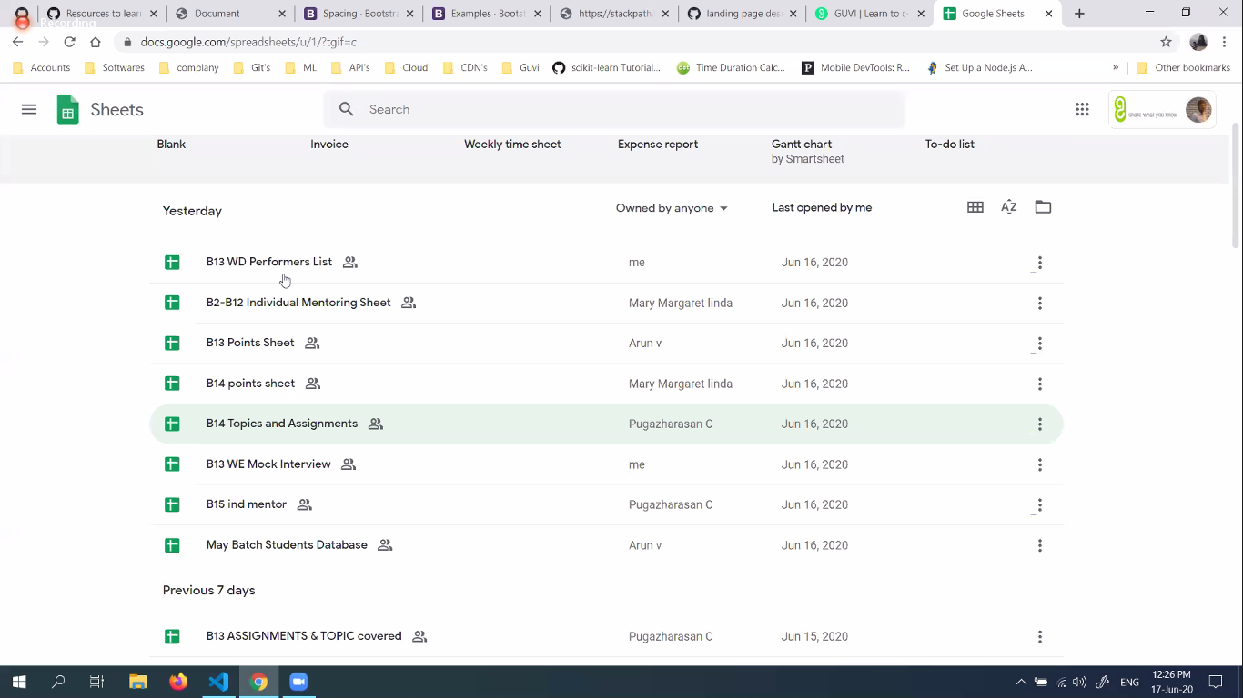

**https://www.linkedin.com/in/deepak-paramesh-4880a9102/**

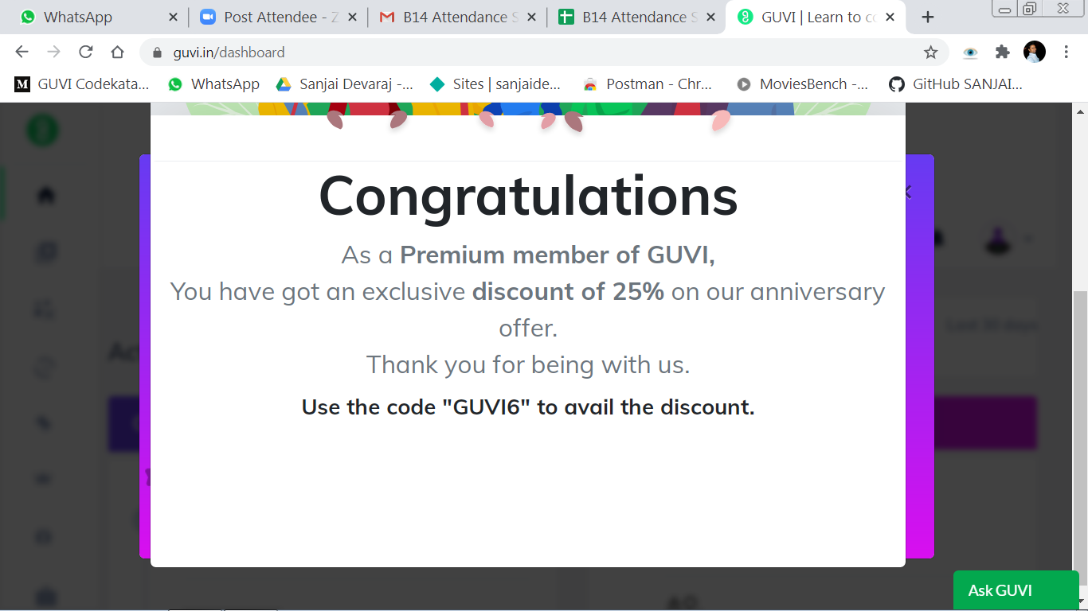

***array, string , mathematics***

[**https://github.com/ryanmcdermott/clean-code-javascript**](https://meet.google.com/linkredirect?authuser=0&dest=https%3A%2F%2Fgithub.com%2Fryanmcdermott%2Fclean-code-javascript)[**https://medium.com/javascript-in-plain-english/javascript-best-practices-for-beginners-b573cbc1ec0f**](https://meet.google.com/linkredirect?authuser=0&dest=https%3A%2F%2Fmedium.com%2Fjavascript-in-plain-english%2Fjavascript-best-practices-for-beginners-b573cbc1ec0f)[**https://www.w3.org/wiki/JavaScript_best_practices**](https://meet.google.com/linkredirect?authuser=0&dest=https%3A%2F%2Fwww.w3.org%2Fwiki%2FJavaScript_best_practices)[**https://blog.risingstack.com/javascript-clean-coding-best-practices-node-js-at-scale/**](https://meet.google.com/linkredirect?authuser=0&dest=https%3A%2F%2Fblog.risingstack.com%2Fjavascript-clean-coding-best-practices-node-js-at-scale%2F)[**http://es6-features.org/**](https://meet.google.com/linkredirect?authuser=0&dest=http%3A%2F%2Fes6-features.org%2F)[**https://codetower.github.io/es6-features/**](https://meet.google.com/linkredirect?authuser=0&dest=https%3A%2F%2Fcodetower.github.io%2Fes6-features%2F)

[**https://www.linkedin.com/in/charlesgodwin/**](https://meet.google.com/linkredirect?authuser=0&dest=https%3A%2F%2Fwww.linkedin.com%2Fin%2Fcharlesgodwin%2F)

[**https://www.facebook.com/charles.godwin.186**](https://meet.google.com/linkredirect?authuser=0&dest=https%3A%2F%2Fwww.facebook.com%2Fcharles.godwin.186)

[https://reactjs.org/docs/cdn-links.html](https://meet.google.com/linkredirect?authuser=0&dest=https%3A%2F%2Freactjs.org%2Fdocs%2Fcdn-links.html)

[https://babeljs.io/setup#installation](https://meet.google.com/linkredirect?authuser=0&dest=https%3A%2F%2Fbabeljs.io%2Fsetup%23installation)

**redux is by next week**

[https://quizzical-khorana-a6b569.netlify.app/](https://meet.google.com/linkredirect?authuser=0&dest=https%3A%2F%2Fquizzical-khorana-a6b569.netlify.app%2F)

***state***

***life cycle events...***

***functional and class components***

***2 videos youtube...***

***https://www.youtube.com/watch?time_continue=1491&v=dpw9EHDh2bM&feature=emb_logo***

***https://github.com/AshikRoyce/getting-started-with-react***

***https://www.youtube.com/watch?v=wXLf18DsV-I&t=1646s***

***assignment - portfolio, counter app - delete , todo list***

***npm -*** npm install -g create-react-app , npm install -g json-server

***,nodejs install , json servs***

***react folder structure..***

[https://www.npmjs.com/package/json-server](https://meet.google.com/linkredirect?authuser=0&dest=https%3A%2F%2Fwww.npmjs.com%2Fpackage%2Fjson-server)

function component

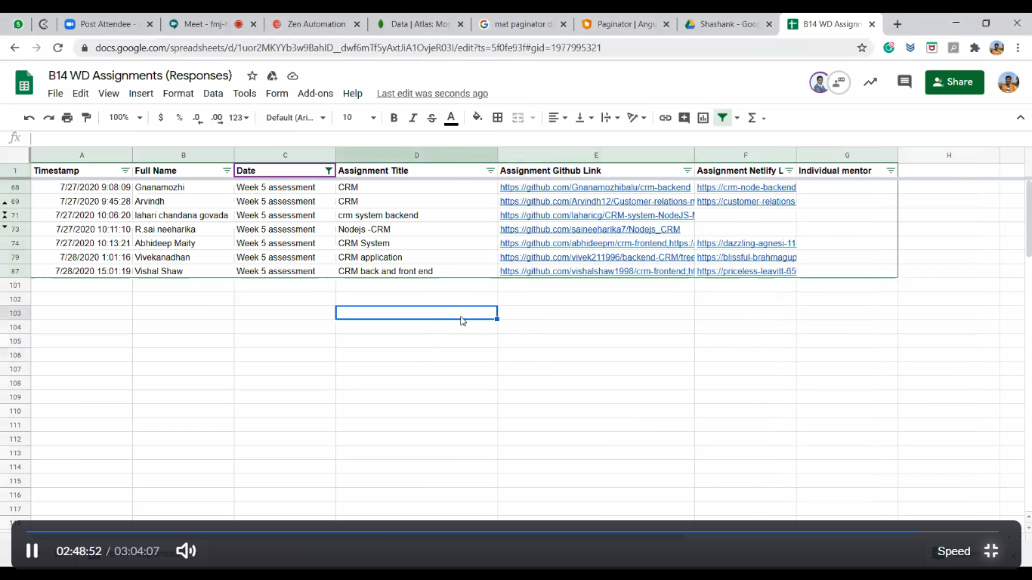

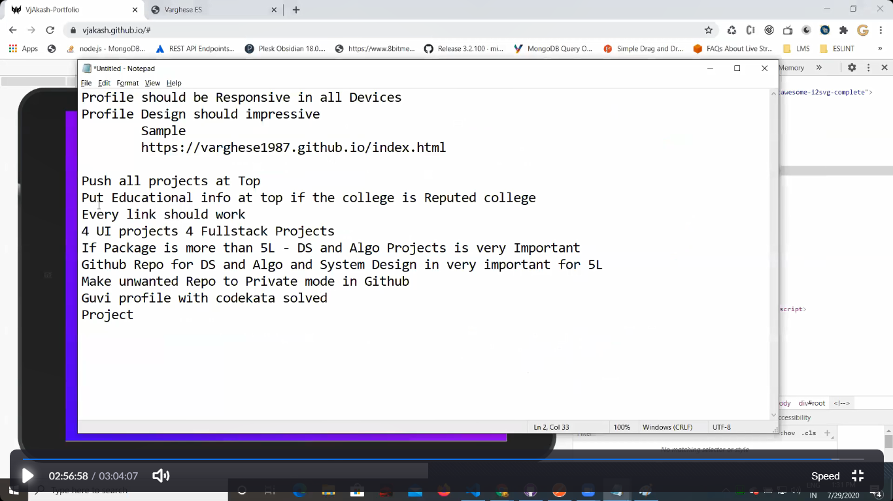

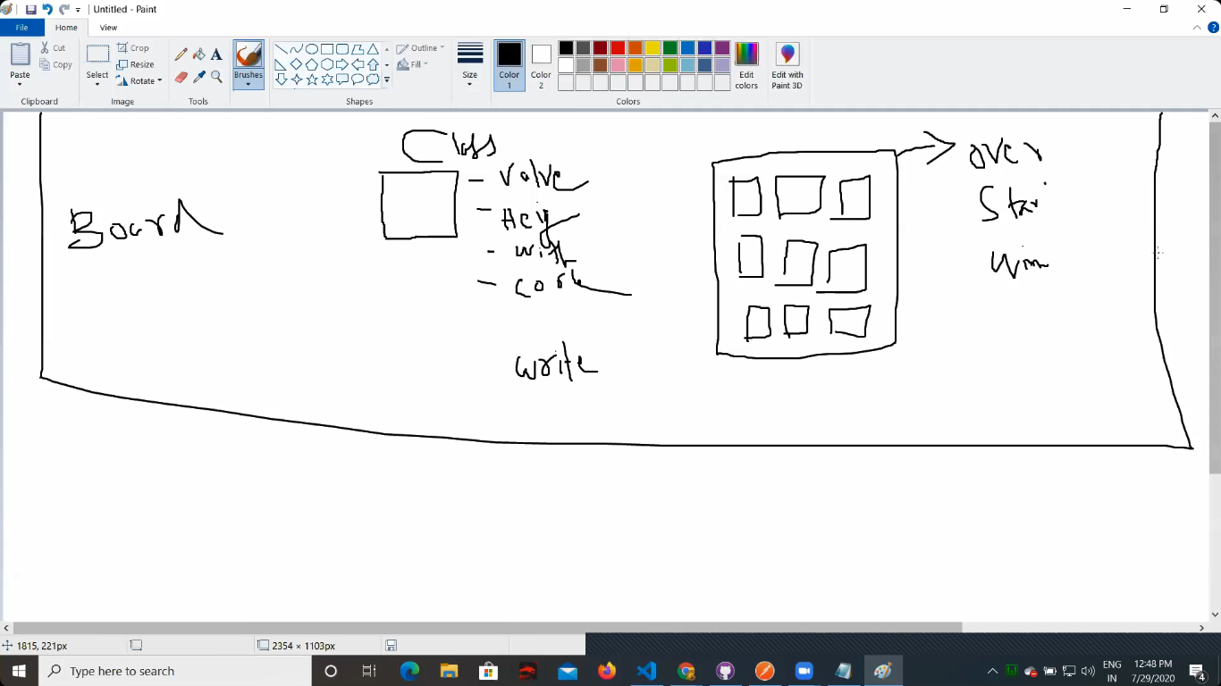

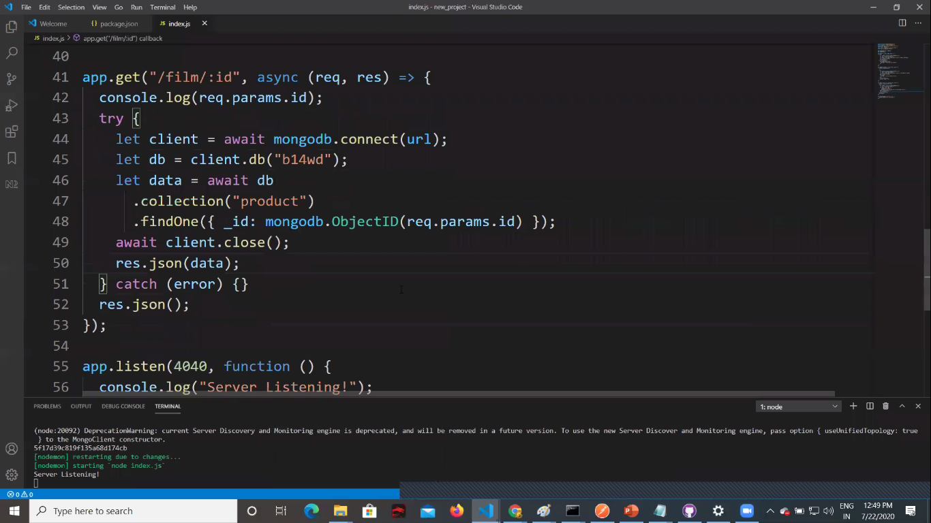

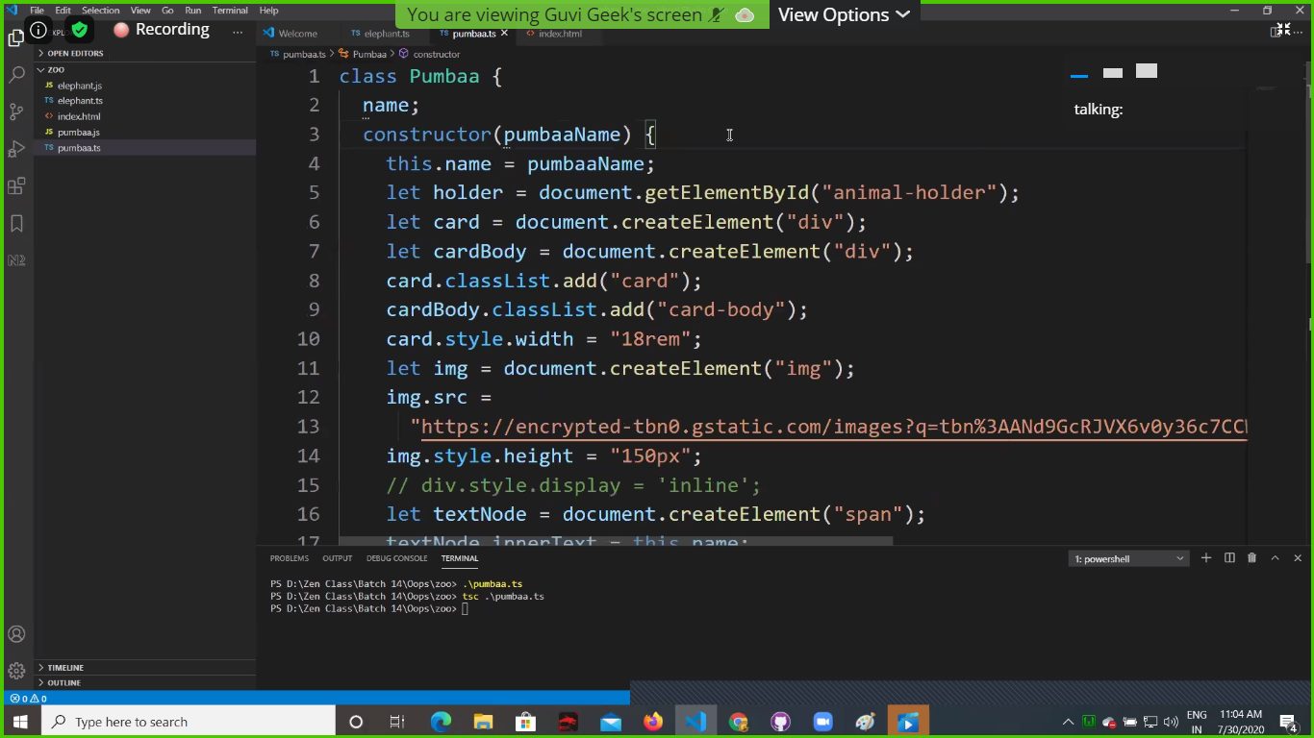

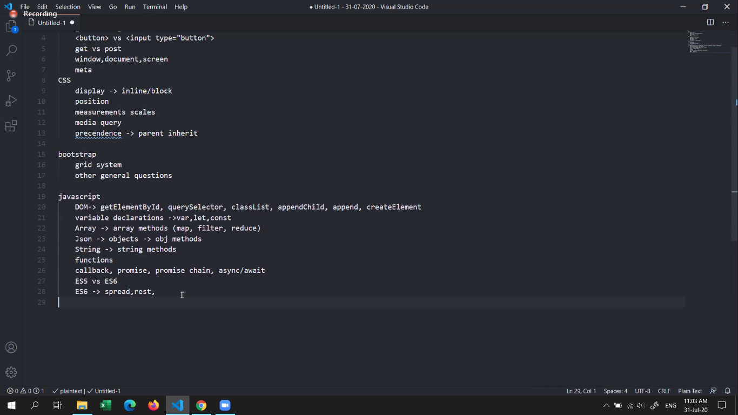

<https://uicookies.com/bootstrap-html-templates/>

<https://www.themezy.com/demos/151-ceevee-free-responsive-website-template>

<https://bootstrapmade.com/bootstrap-portfolio-templates/>

<https://bootstrapmade.com/demo/MyResume/>

<https://startbootstrap.com/themes/portfolio-resume/>

<https://themeforest.net/category/all>

<https://github-readme-stats.vercel.app/api?username=sanjaidevaraj&show_icons=true&hide_border=true>

<https://www.netlify.com/tags/webpack/>

<https://stackedit.io/>

<https://dillinger.io/>

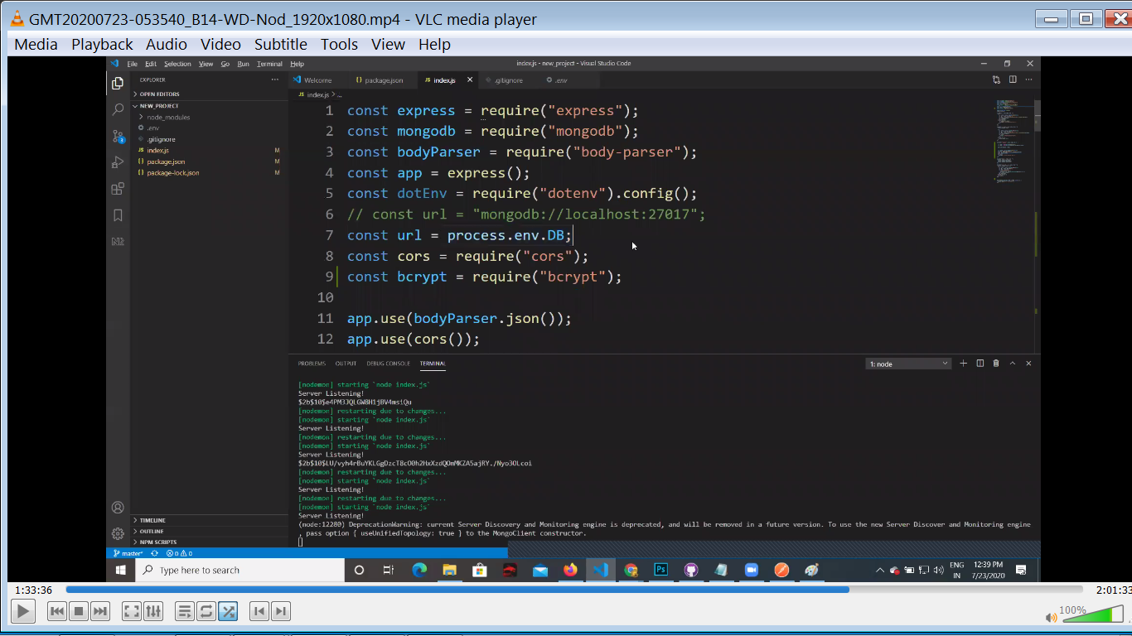

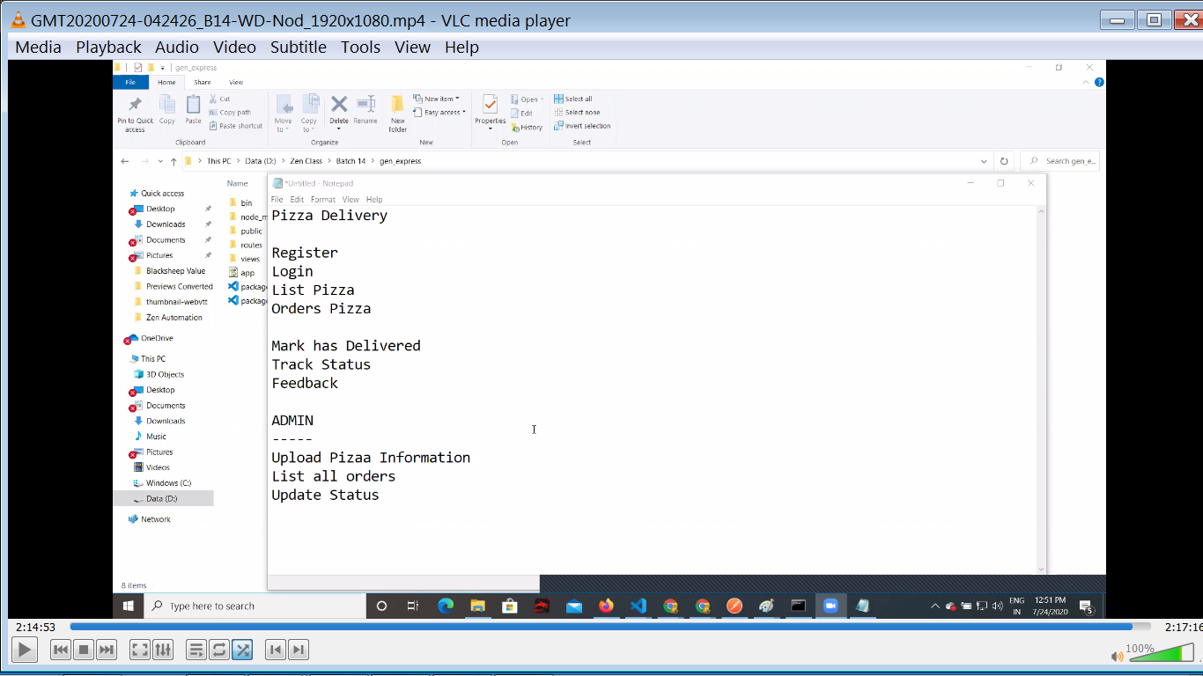

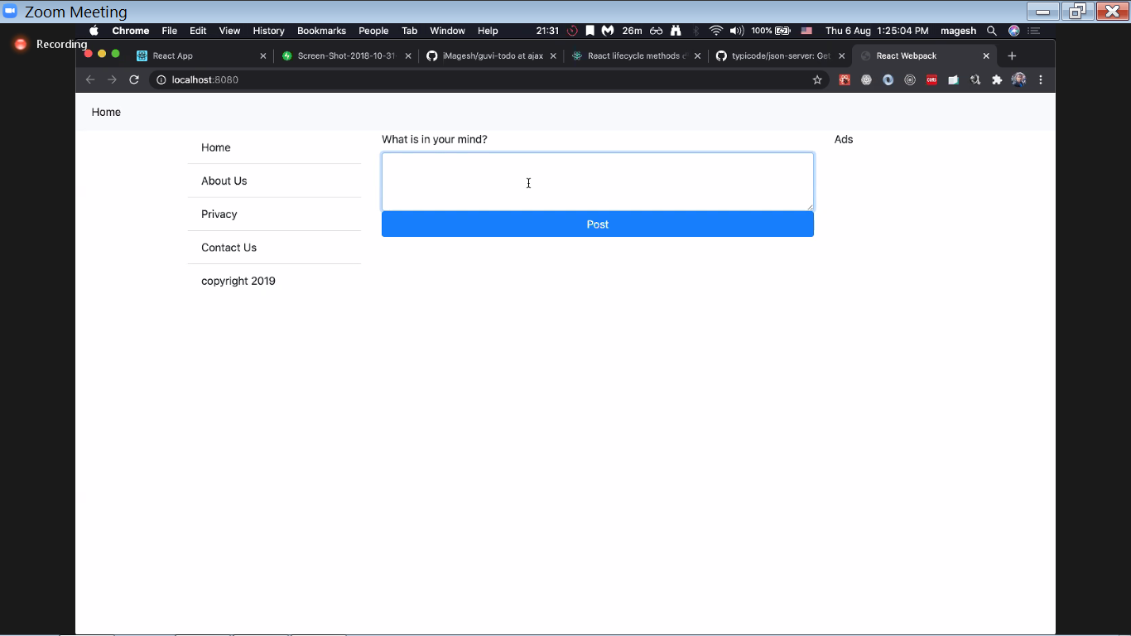

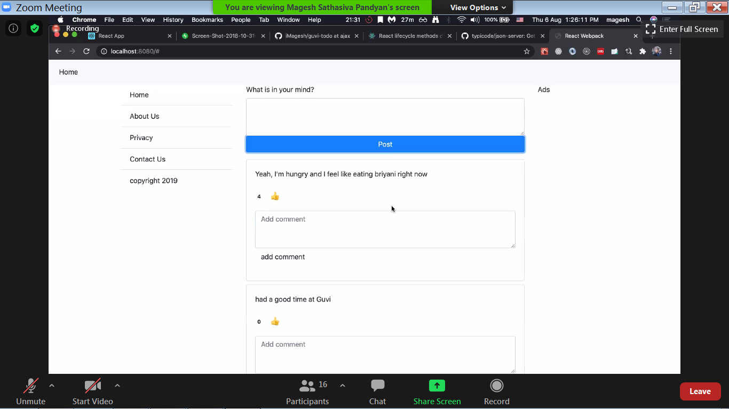

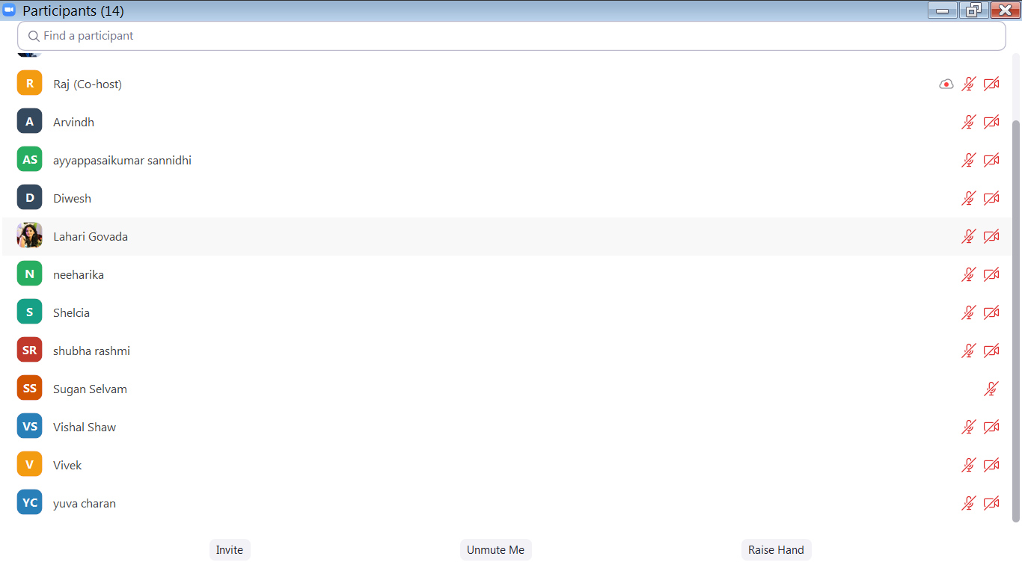

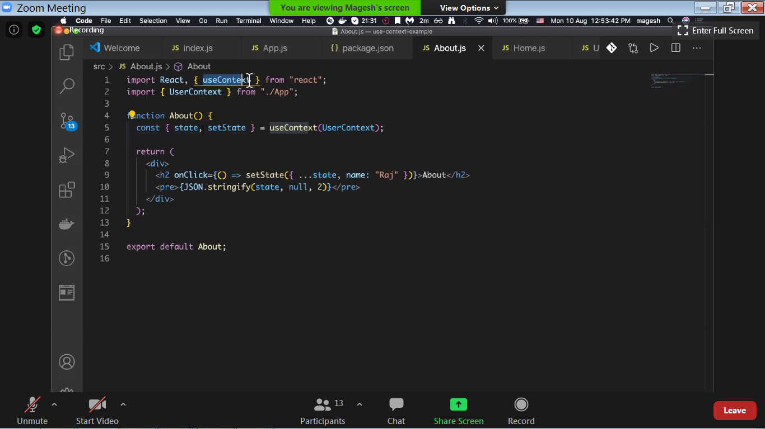

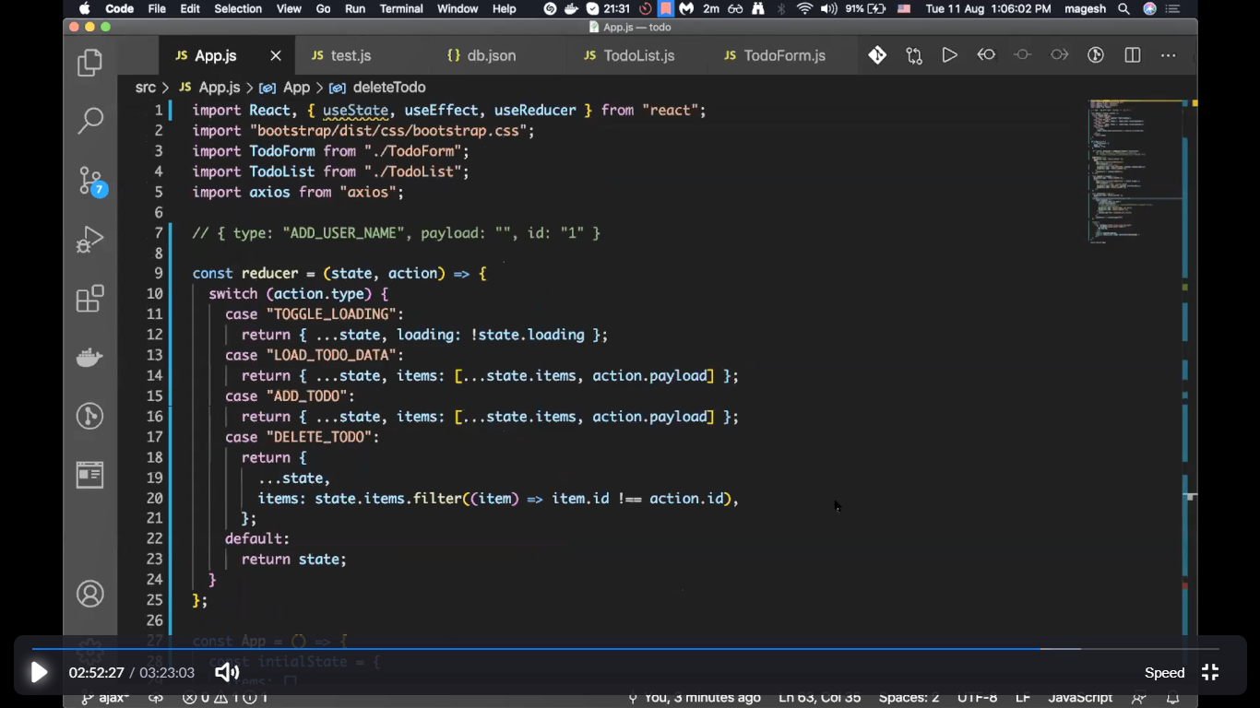

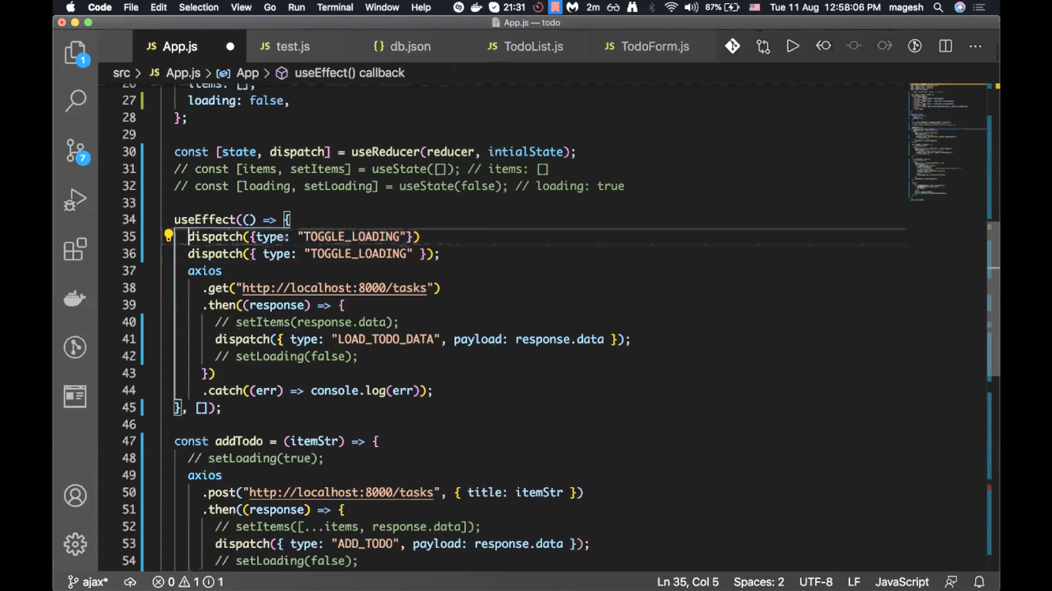

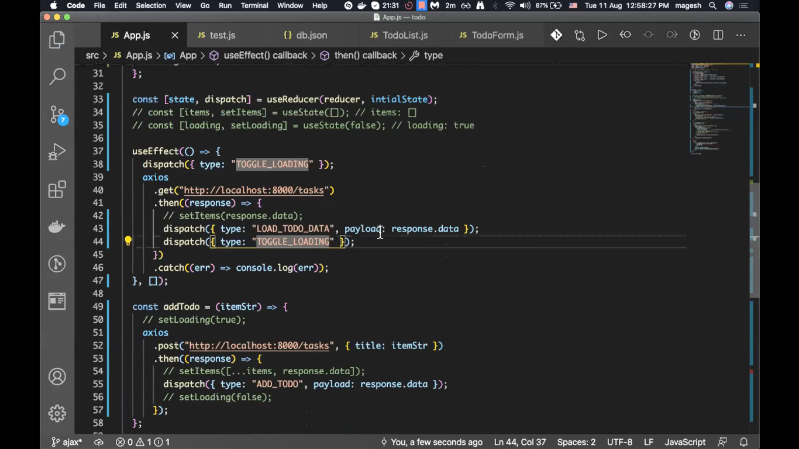

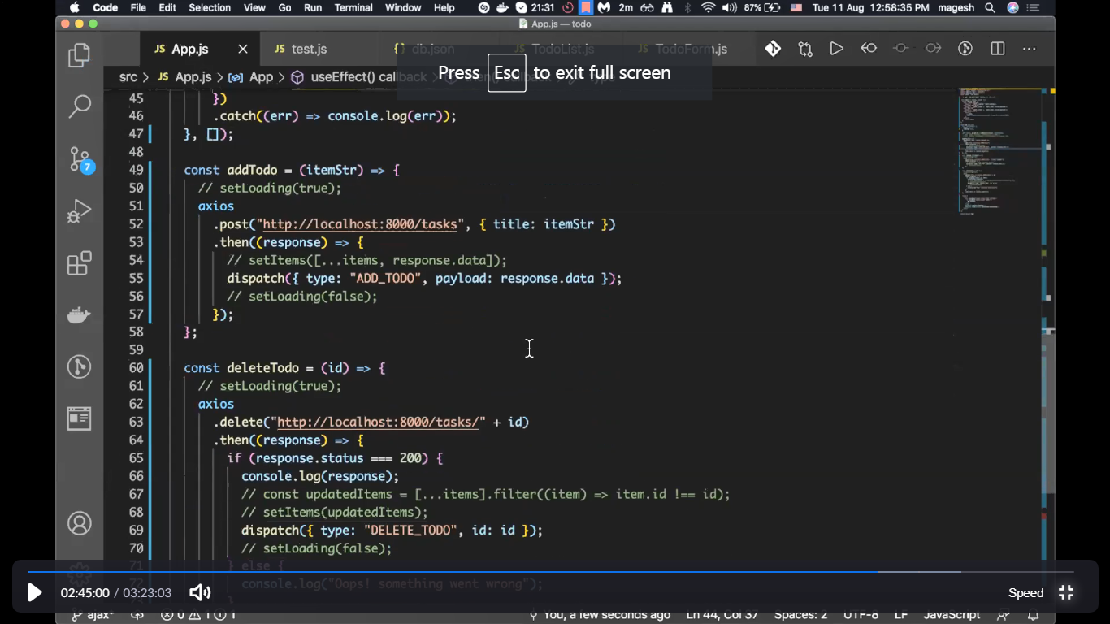

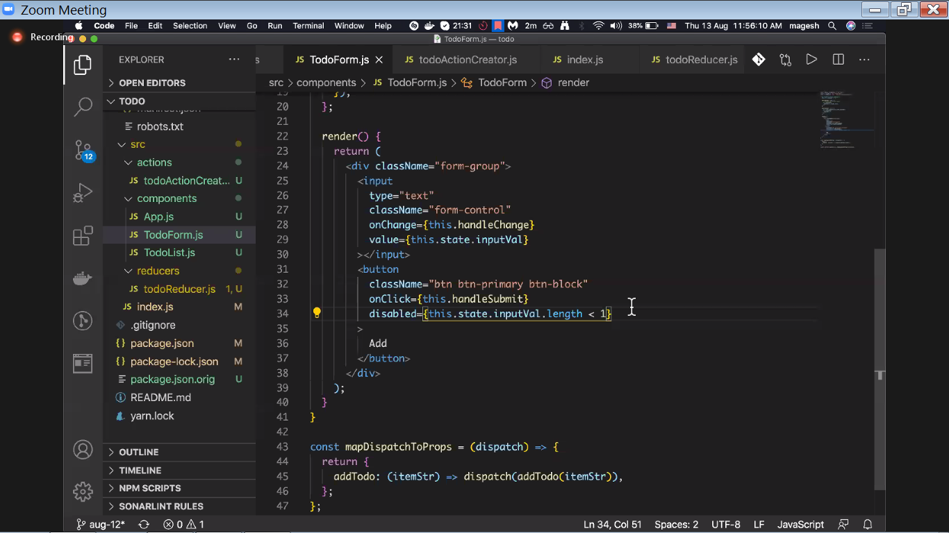

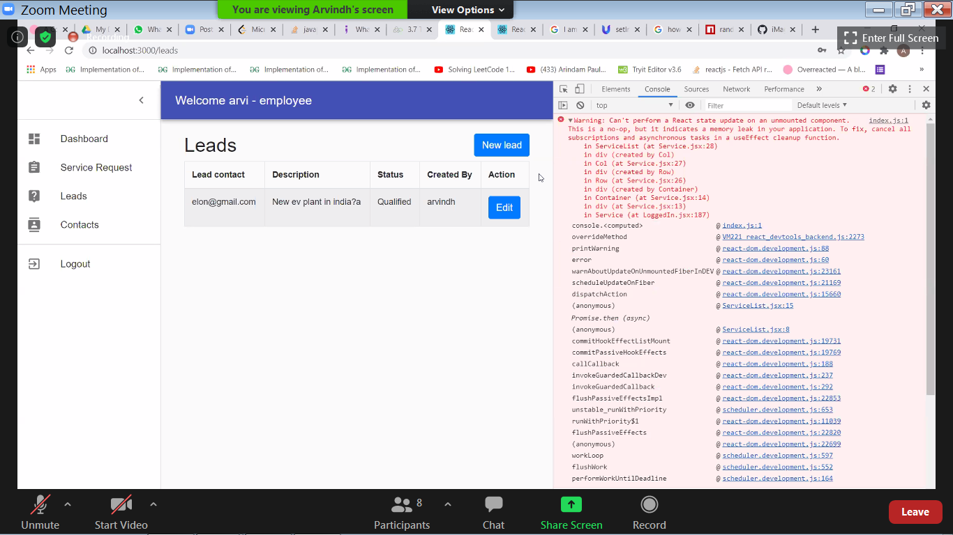

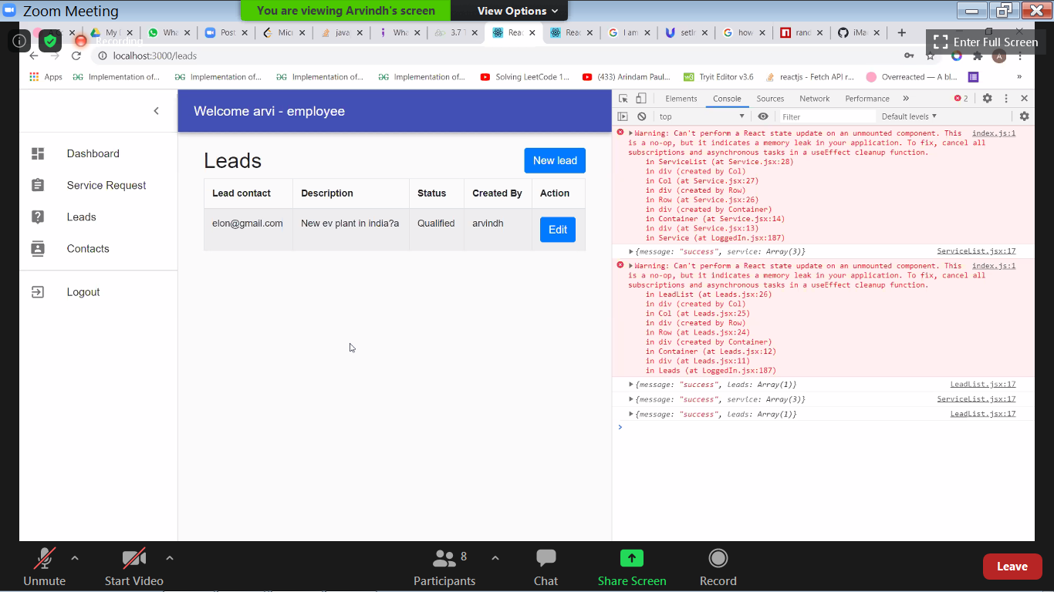

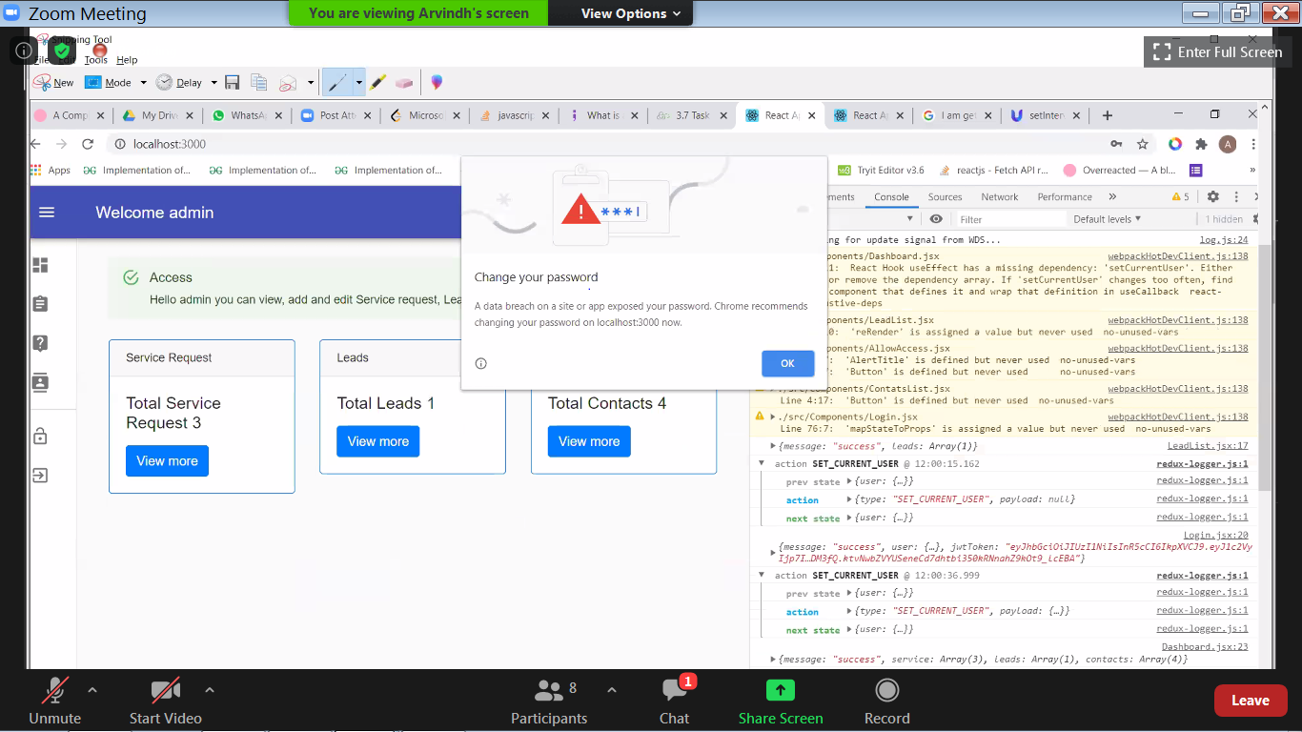

***https://docs.google.com/presentation/d/1mcrdJEjsM3buGQXLLKvHw5Qbl_1ekE2nsYOllktMuek/edit?usp=sharing***